**EXPERIMENT 15:** CREATE A CLONING OF A VM AND TEST IT BY LOADING THE PREVIOUS VERSION/CLONED VM**.**

**AIM:**

To create a cloning of a vm and test it by loading the previous version/cloned vm.

**PROCEDURE:**

**STEP 1**: GO TO VM AND GOTO MANAGE AND CLICK CLONE

**STEP 2:** CLICK CLONE

**STEP 3:** SELECT THE FULL CLONE

**STEP 4**: AFTER CLONE AGAIN OR VM IS OPENED.

**IMPLEMENTATION:**

**1.Create a Virtual machine named vmware1**

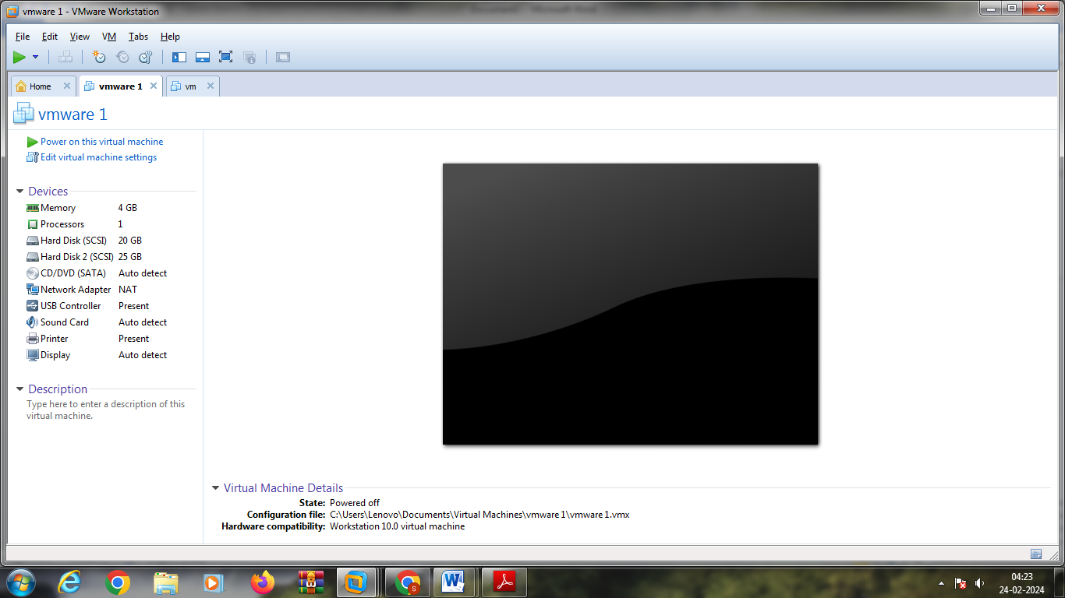

**2.Select VM and select manage and click clone**

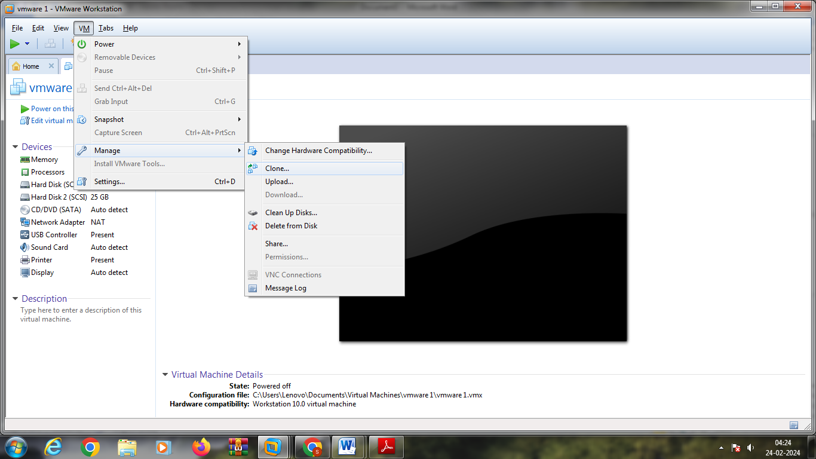

**3.Implementing following steps**

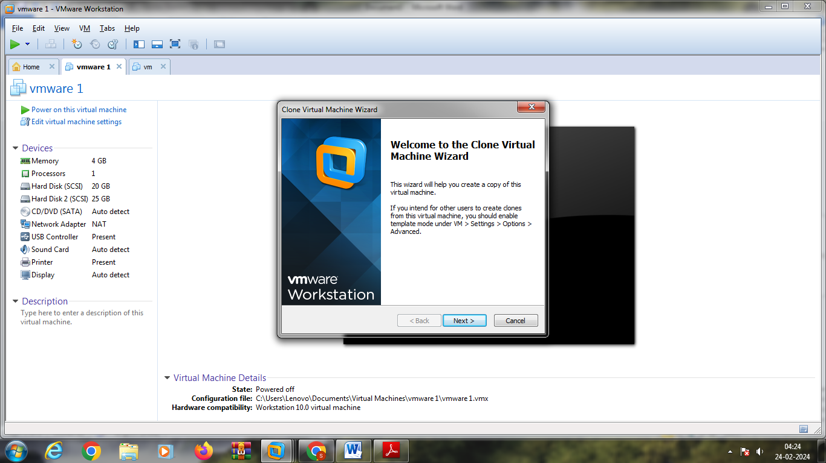

4.

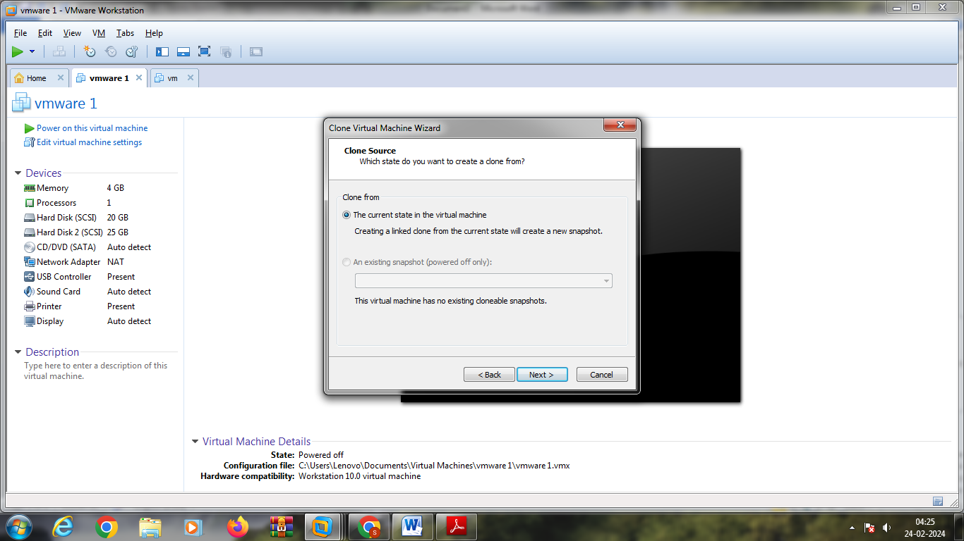

**5.Select create a full clone**

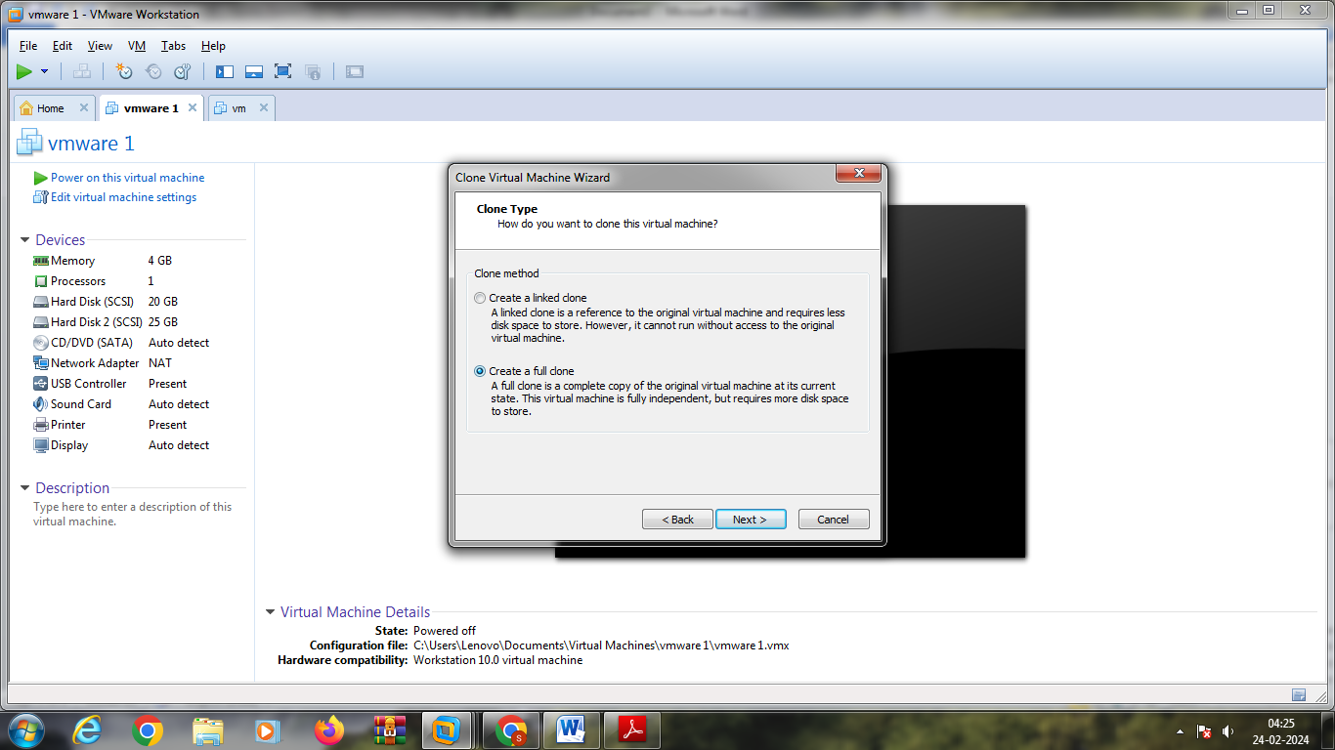

**6.Name the clone**

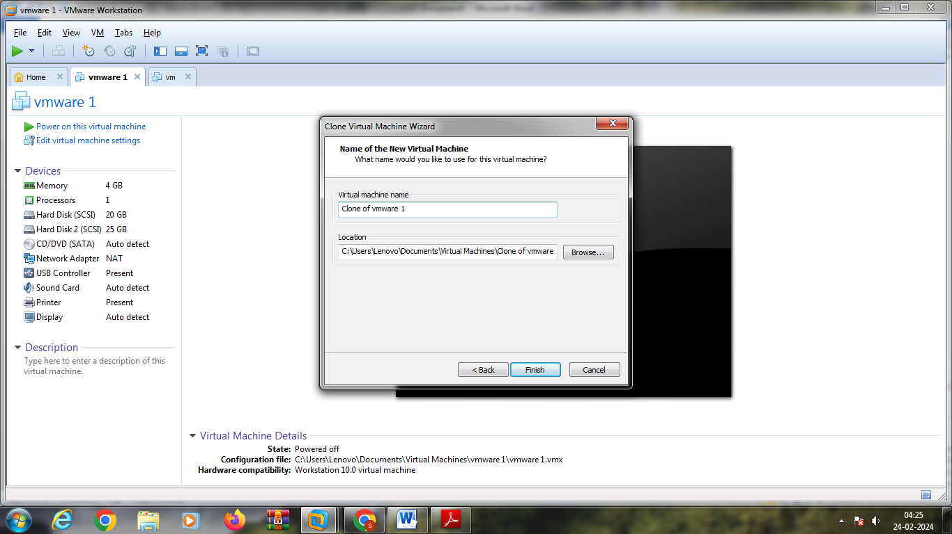

**7.cloning done**

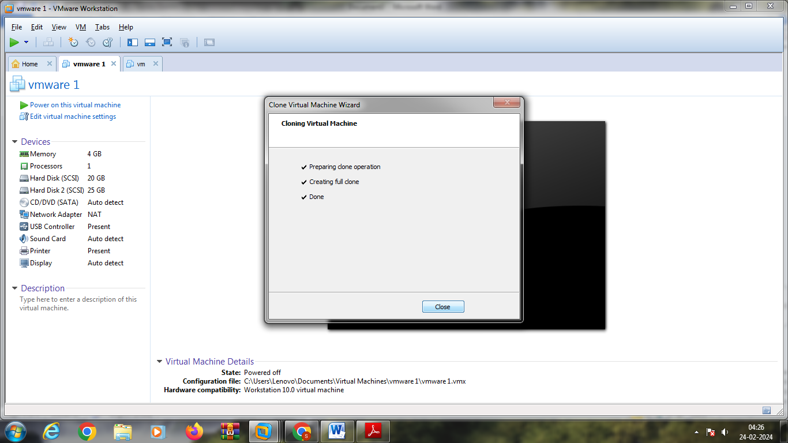

**8.Clone of vmware 1**

